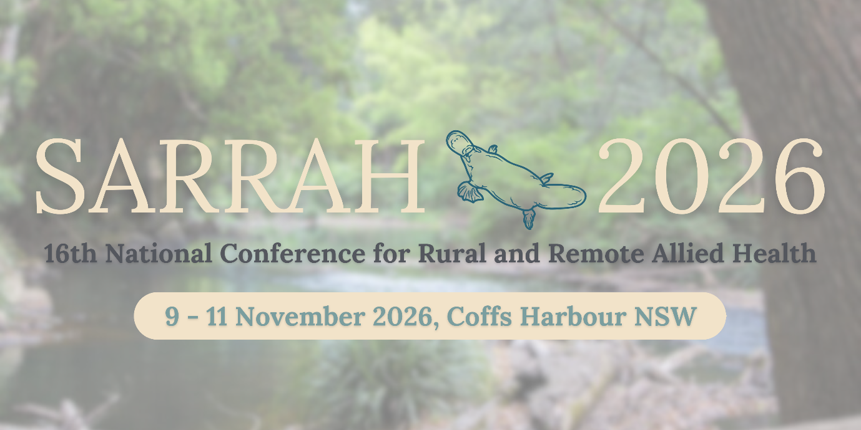

The SARRAH 2026 Conference Scientific Committee invites you to submit an abstract for presentations that address the conference theme and subthemes.

Theme:

A sense of place: Embracing Local Knowledge Subthemes:
- Cultural Responsiveness and Sustainability
- Local Wisdom in Action
- Improving Access to Care
The National Conference for Rural and Remote Allied Health is the centrepiece of SARRAH’s engagement with our members and all allied health professionals, service providers, academics, students, and local, state and Commonwealth governments, working to ensure equitable access to allied health services and better health outcomes for rural and remote Australians. The purpose of our gathering is to share knowledge and thought leadership in the rural and remote allied health sector while networking with new and old friends.
The 2026 theme A sense of place: Embracing Local Knowledge marks the 16th National Conference for Rural and Remote Allied Health, and we plan to make this event the best yet!
SARRAH 2026- held in Coffs Harbour, NSW, will bring together health leaders with a shared vision of growing a fit-for-purpose rural and remote health workforce committed to caring for rural and remote Australians, so that they have access to the healthcare they need to stay whole, healthy, and fully participating in society.
Together we will respond to health system challenges, sharing our stories and celebrating best practice while creating opportunities for innovation and collaboration.
We encourage you to join in the conversation - be a part of the movement to nurture sustainable and resilient rural and remote communities!

Presentation streams
As part of the abstract process, you will be asked to indicate your choice of two options.

1. General stream - oral presentation only
You may choose to provide your presentation for publication in the conference proceedings.

2. Scientific Stream – oral presentation and refereed paper, published after conference
The peer reviewed scientific stream will again be offered at the 2026 National SARRAH Conference. Authors submitting in this stream will have the opportunity to have their papers peer reviewed and published. Details will be confirmed at a later date.

Abstract formats
We invite you to submit abstracts in the formats below. While you will be asked to indicate your preferred presentation format when submitting your abstract, the Committee may request an alternative format be considered. The Committee will allocate the format of presentations, taking into account the preference of authors and the balance of the program.
Abstracts may be in the style of:
- A narrative or story outline; or
- A traditional structure comprising aims, methods, results and discussion / recommendations.

Abstract submissions
Authors are invited to submit abstracts of 300 words by COB 1st March 2026.
Abstracts may be in the style of:
- A narrative or story outline; or
- A traditional structure comprising: aims, methods, results and discussion / recommendations.

All abstracts are to be submitted electronically via the following link:
https://app.oxfordabstracts.com/stages/79153/submitter

If you have any queries, please contact SARRAH by email at sarrah@sarrah.org.au or Conference@sarrah.org.au

Presentation types

Standard oral presentation: 15 min (12min presentation, 3 min questions)
Format: oral presentation (12 minutes) and questions (3 minutes).
Abstract: traditional 300-word abstract with suggested format: Introduction, Methods, Results / Outcomes, Discussion / Learnings, Conclusion / Recommendation.
This presentation format is suited to:
- Presentation of a service project or research study
- Presentations of significant impact or importance for rural and remote allied health
- Topics requiring discussion of context prior to delivering the results and summary/conclusion

Lightning Presentations- some followed by Panel Discussion
Format: oral presentation (5 minutes). The session structure is 4 x 5-minute presentations that will be linked by a theme. Following the last presentation, the 4 presenters are positioned at stations in the room and audience members can approach the presenter/s of their choice to ask questions and discuss the topic further, OR are seated at the front for a panel discussion. Presenters are also encouraged to show and share resources with the audience. The questions/panel discussion section lasts 10 mins.
Abstract: 300-word abstract in the format:
- What we did (methods, activities),
- What we produced (description of the change/ improvement, new resources or process and an evaluation finding/outcome),
- What we learned.
The presentation format is suited to:
- Local quality improvement or service innovation activities, pilot project with results available to present to peers (projects / activities presented should have at least intermediate results / outcomes described in the abstract)
- Sharing evaluated resources (clinical tools, patient resources, service coordination tools)
- Forming collaborations and identifying contacts and colleagues doing similar work

Panel Discussion: 60 minutes
Format: facilitator and 3 panel members will discuss and work with the audience members on a key topic for rural and remote allied health i.e. a wicked problem or a system priority.
- Facilitator introduces topic including presenting key data and summarising issues, and defining the outcome of the seminar (5 mins)
- Panel members provide key insights from practice, policy and research (up to 5 minutes each)
- Facilitated discussion with audience contributing their perspectives, experiences, learnings / solutions / strategies
- The seminar should be action-orientated and stimulate discussion and one or more recommendations that can be reported as part of the conference outcomes and progressed by stakeholders (SARRAH members and partners).
Abstract: 300 words
- Panel Discussion outline up to 300 words (brief description of issue / problem and rationale for presenting it as a priority for the conference, expected outcome of seminar), and
- Facilitator and presenter biographies. Presenters should provide diversity of perspectives and experience of the topic. This may include sectors (e.g. public, private, NGO, community controlled), experiences (e.g. clinicians, managers, policy, education, research, consumer, advocate, associated industries such as vendors/suppliers), career stages (students/early career, mid-career, “venerable colleagues”), geographical spread (national or international, urban/rural/remote).
- The Scientific committee may propose and work with seminar presenters to address priority topics.
This presentation format is suited to:
- Current and emerging issues and priorities for rural and remote healthcare
- Collaborative discussion focussed on opportunities, scaling and spreading local/regional solutions, defining priorities for action and practical strategies that audience members and SARRAH can progress.

Poster
Format: Posters will be physically printed and displayed. Pwill be displayed for the duration of the conference in the exhibition and catering area. Accepted poster authors will be sent instructions for preparing their Poster. Presenters are encouraged to include a QR code so delegates can access relevant publically available information.
Abstract: 300 words
This presentation is suited to:
- Traditional poster topics e.g. local projects, QI activities, small research projects (honours research, dissertation) etc
- Topics may have narrower relevance that those selected for the Rapid 5 or lend themselves better to visual presentation (data, charts, graphics).
- Times will be scheduled for people to connect with poster authors.

Creative Arts
Format:
This submission type invites participants to explore and express themes of rural and remote allied health through artistic and creative mediums. Creative Arts presentations may include (but are not limited to) visual art, photography, film, music, poetry, storytelling, performance, installation, or multimedia works. These submissions offer powerful ways to communicate lived experience, cultural identity, community connection, and place-based wisdom.
Creative works may be presented as standalone exhibits, interactive sessions, or integrated into workshops or panels. Submissions should describe the artistic medium, the message or story being conveyed, and how the work relates to the conference themes. We particularly welcome works that reflect cultural responsiveness, local knowledge, and the emotional and relational dimensions of health care in rural and remote settings.
Space and technical requirements should be outlined in the abstract to support planning. Collaborative and community-created works are strongly encouraged.

Abstract: 300 words

Culturally Grounded Sessions

Format:

This submission type honours First Nations ways of knowing, being, and doing by creating space for culturally grounded formats that support deep listening, storytelling, and relational learning. These sessions may include yarning circles, weaving workshops, song and dance, ceremonial practices, or other forms of cultural expression and knowledge sharing. They are designed to foster respectful dialogue, connection to Country, and collective reflection.

Submissions in this category should be led or co-led by First Nations peoples or communities, and reflect cultural protocols and practices. These formats are not only educational, they are relational, healing, and transformative. They invite participants to slow down, listen deeply, and engage with knowledge that is embodied, intergenerational, and place-based.

Abstracts should outline the cultural context, purpose, and intended experience of the session, as well as any specific requirements (e.g. space, materials, time, or cultural safety considerations). We encourage submissions that centre First Nations voices and uphold principles of self-determination, respect, and reciprocity.

Abstract: 300 words

Participatory sessions
Format:
This submission type invites facilitators to lead interactive, participatory sessions that foster shared learning, diverse perspectives, and practical skill development. These sessions may take the form of structured workshops, facilitated conversations, or collaborative panels, and are designed to engage participants in meaningful dialogue, experiential learning, and collective problem-solving.
Workshops may focus on building specific competencies, exploring innovative models of care, or applying theory to practice through hands-on activities. Conversations and panels may centre around complex issues, emerging trends, or lived experiences, with an emphasis on respectful exchange and mutual learning.
Submissions should outline the session format, intended outcomes, facilitation approach, and how the session aligns with the conference themes. We encourage formats that are inclusive, reflective, and responsive to the needs and strengths of rural and remote allied health and communities.

Abstract: 300 words

Embedded research activities

Format:

This submission type invites researchers to design and conduct ethical, participatory research activities during the conference itself, engaging attendees as collaborators, contributors, or co-researchers. Embedded research offers a unique opportunity to explore real-time insights, test ideas, or gather data in a dynamic, practice-informed environment. Projects should include interactive methods (e.g. interviews, focus groups, creative inquiry, participatory mapping).

Researchers must obtain ethical approval prior to the conference and provide documentation upon acceptance. Abstracts should clearly outline the research aims, methodology, participant engagement strategy, and how the research aligns with the conference themes. Space and scheduling requirements should also be noted to support planning.

This format is ideal for those seeking to co-create knowledge with rural and remote allied health professionals, community members, and other stakeholders in a respectful and responsive way.

Abstract: 300 words

Pre-conference workshop: 3 hours/ half-day
Format: Facilitators will workshop a key topic for rural and remote allied health i.e. a wicked problem or a system priority.
The workshop should be action-orientated and stimulate discussion and one or more recommendations that can be reported as part of the conference outcomes and progressed by stakeholders (SARRAH members and partners).
Abstract: 300 words
- The abstract is your initial pitch for an idea for a pre-conference workshop.
- Workshop outline up to 300 words (brief description of issue / problem and rationale for presenting it as a priority for the conference, expected outcome of workshop), and
- Facilitator and presenter biographies
- The Committee may request more information as required.

